Name of Student : Raghav Mahesh Sarda PRN: 25070122235
Subject: Programming with Java Semester: III
ASSIGNMENT No : 20 Year: AY 2026-27
TITLE : JDBC INSERT, UPDATE, and DELETE Operations

Problem Statement
Develop a Java application to establish connectivity with a database and perform INSERT, UPDATE, and DELETE operations.

Learning Objectives
To perform database modification operations using JDBC.

Program:
sit_java.sql
CREATE DATABASE sit_java;
USE sit_java;

-- Assignment 19
-- Table for Exercise 1
CREATE TABLE student (
roll_no INT PRIMARY KEY,
name VARCHAR(50),
course VARCHAR(50),
marks DOUBLE
);

INSERT INTO student VALUES
(101, 'Raghav Sarda', 'Computer Science', 92.5),
(102, 'Parth Kulkarni Sarda', 'Computer Science', 94.5),
(103, 'Yatharth Shah', 'Computer Science', 93.5);

-- Table for Exercise 2
CREATE TABLE product (
product_id INT PRIMARY KEY,
product_name VARCHAR(50),
quantity INT,
price DOUBLE
);

INSERT INTO product VALUES
(501, 'Logitech MX Master 4 Mouse', 10, 16000),
(502, 'Apple Magic Keyboard', 20, 18000),
(503, 'Apple Studio Display', 15, 179999);

-- Assignment 20
-- Table for Exercise 1
CREATE TABLE employee (
emp_id INT PRIMARY KEY,
name VARCHAR(50),
department VARCHAR(50),
salary DOUBLE
);

-- Table for Exercise 2
CREATE TABLE student_crud (
roll_no INT PRIMARY KEY,
name VARCHAR(50),
course VARCHAR(50),
marks DOUBLE
);

EmployeeCRUD.java
// Assignment 20 - Exercise 1: Employee Records CRUD Operations
import java.sql.*;
import java.util.*;
public class EmployeeCRUD
{
public static void main(String args[]) // Main Method
{
Scanner sc = new Scanner(System.in);
String url = "jdbc:mysql://localhost:3306/sit_java"; // DB URL
String user = "thegharkalaptop"; // DB Username
String pass = ""; // DB Password

try
{
Class.forName("com.mysql.cj.jdbc.Driver"); // Registering driver
Connection con = DriverManager.getConnection(url, user, pass); // Connecting to DB

while(true) // Menu loop
{
System.out.println("\n-- Employee CRUD Operations --"); // Menu
System.out.println("1. Create (Insert) Employee");
System.out.println("2. Read (View) Employees");
System.out.println("3. Update Employee Salary");
System.out.println("4. Delete Employee Record");
System.out.println("5. Exit");
System.out.print("Enter choice: ");
int choice = sc.nextInt();

if(choice == 1) // INSERT
{
System.out.print("Enter ID: ");
int id = sc.nextInt();
sc.nextLine(); // Consuming newline
System.out.print("Enter Name: ");
String name = sc.nextLine();
System.out.print("Enter Department: ");
String dept = sc.nextLine();
System.out.print("Enter Salary: ");
double sal = sc.nextDouble();

String sql = "INSERT INTO employee VALUES (?, ?, ?, ?)"; // Parameterized query
PreparedStatement ps = con.prepareStatement(sql); // Preparing statement
ps.setInt(1, id);
ps.setString(2, name);
ps.setString(3, dept);
ps.setDouble(4, sal);
ps.executeUpdate(); // Executing DML
System.out.println("Employee record inserted successfully!");
ps.close(); // Closing PreparedStatement
}
else if(choice == 2) // SELECT
{
Statement stmt = con.createStatement(); // Creating Statement
ResultSet rs = stmt.executeQuery("SELECT * FROM employee"); // Executing SELECT
System.out.println("\nID\tName\t\tDepartment\tSalary");
while(rs.next()) // Traversing records
{
System.out.println(rs.getInt(1) + "\t" + rs.getString(2) + "\t" + rs.getString(3) + "\t" + rs.getDouble(4));
}
rs.close();
stmt.close(); // Closing Statement
}
else if(choice == 3) // UPDATE
{
System.out.print("Enter Employee ID to update: ");
int id = sc.nextInt();
System.out.print("Enter New Salary: ");
double newSal = sc.nextDouble();

String sql = "UPDATE employee SET salary = ? WHERE emp_id = ?"; // UPDATE query
PreparedStatement ps = con.prepareStatement(sql); // Preparing statement
ps.setDouble(1, newSal);
ps.setInt(2, id);
int rows = ps.executeUpdate(); // Executing update
if(rows > 0) System.out.println("Salary updated successfully!");
else System.out.println("Employee ID not found.");
ps.close(); // Closing PreparedStatement
}
else if(choice == 4) // DELETE
{
System.out.print("Enter Employee ID to delete: ");
int id = sc.nextInt();

String sql = "DELETE FROM employee WHERE emp_id = ?"; // DELETE query
PreparedStatement ps = con.prepareStatement(sql); // Preparing statement
ps.setInt(1, id); // Binding ID
int rows = ps.executeUpdate(); // Executing delete
if(rows > 0) System.out.println("Employee deleted successfully!");
else System.out.println("Employee ID not found.");
ps.close(); // Closing PreparedStatement
}
else if(choice == 5) // EXIT
{
System.out.println("Exiting application...");
break;
}
}
con.close(); // Closing DB Connection
}
catch(Exception e) // Catching exceptions
{
System.out.println("Error: " + e.getMessage());
}
sc.close();
}
}

StudentCRUD.java
// Assignment 20 - Exercise 2: Student Records CRUD Operations (Roll, Name, Course, Marks)
import java.sql.*;
import java.util.*;
public class StudentCRUD
{
public static void main(String args[]) // Main Method
{
Scanner sc = new Scanner(System.in);
String url = "jdbc:mysql://localhost:3306/sit_java"; // DB URL
String user = "thegharkalaptop"; // DB Username
String pass = ""; // DB Password

try // Try block
{
Class.forName("com.mysql.cj.jdbc.Driver"); // Registering driver
Connection con = DriverManager.getConnection(url, user, pass); // Connecting to DB

while(true)
{
System.out.println("\n-- Student Management System (CRUD) --"); // Menu
System.out.println("1. Add Student (Create)");
System.out.println("2. View All Students (Read)");
System.out.println("3. Update Student Marks (Update)");
System.out.println("4. Delete Student Record (Delete)");
System.out.println("5. Exit");
System.out.print("Enter choice: ");
int choice = sc.nextInt();

if(choice == 1) // CREATE
{
System.out.print("Enter Roll Number: ");
int roll = sc.nextInt();
sc.nextLine(); // Consuming newline
System.out.print("Enter Student Name: ");
String name = sc.nextLine();
System.out.print("Enter Course: ");
String course = sc.nextLine();
System.out.print("Enter Marks: ");
double marks = sc.nextDouble();

String sql = "INSERT INTO student_crud VALUES (?, ?, ?, ?)"; // Parameterized query
PreparedStatement ps = con.prepareStatement(sql); // Preparing query
ps.setInt(1, roll);
ps.setString(2, name);
ps.setString(3, course);
ps.setDouble(4, marks);
ps.executeUpdate(); // Executing insert
System.out.println("Student record added successfully!");
ps.close(); // Closing statement
}
else if(choice == 2) // READ
{
Statement stmt = con.createStatement(); // Creating statement
ResultSet rs = stmt.executeQuery("SELECT * FROM student_crud"); // Executing read
System.out.println("\nRoll No\tName\t\tCourse\t\tMarks");
while(rs.next()) // Looping through results
{
System.out.println(rs.getInt(1) + "\t" + rs.getString(2) + "\t" + rs.getString(3) + "\t" + rs.getDouble(4));
}
rs.close(); // Closing ResultSet
stmt.close(); // Closing Statement
}
else if(choice == 3) // UPDATE
{
System.out.print("Enter Roll Number to update: ");
int roll = sc.nextInt();
System.out.print("Enter New Marks: ");
double newMarks = sc.nextDouble();

String sql = "UPDATE student_crud SET marks = ? WHERE roll_no = ?"; // Update query
PreparedStatement ps = con.prepareStatement(sql); // Preparing statement
ps.setDouble(1, newMarks);
ps.setInt(2, roll);
int rows = ps.executeUpdate(); // Executing update
if(rows > 0) System.out.println("Marks updated successfully!");
else System.out.println("Student roll number not found.");
ps.close(); // Closing statement
}
else if(choice == 4) // DELETE
{
System.out.print("Enter Roll Number to delete: ");
int roll = sc.nextInt();

String sql = "DELETE FROM student_crud WHERE roll_no = ?"; // Delete query
PreparedStatement ps = con.prepareStatement(sql); // Preparing statement
ps.setInt(1, roll);
int rows = ps.executeUpdate(); // Executing deletion
if(rows > 0) System.out.println("Student record deleted successfully!");
else System.out.println("Student roll number not found.");
ps.close(); // Closing statement
}
else if(choice == 5) // EXIT
{
System.out.println("Exiting Student System...");
break;
}
}
con.close(); // Closing connection
}
catch(Exception e) // Catching exceptions
{
System.out.println("Error: " + e.getMessage());
}
sc.close();
}
}

Output:
EmployeeCRUD.java
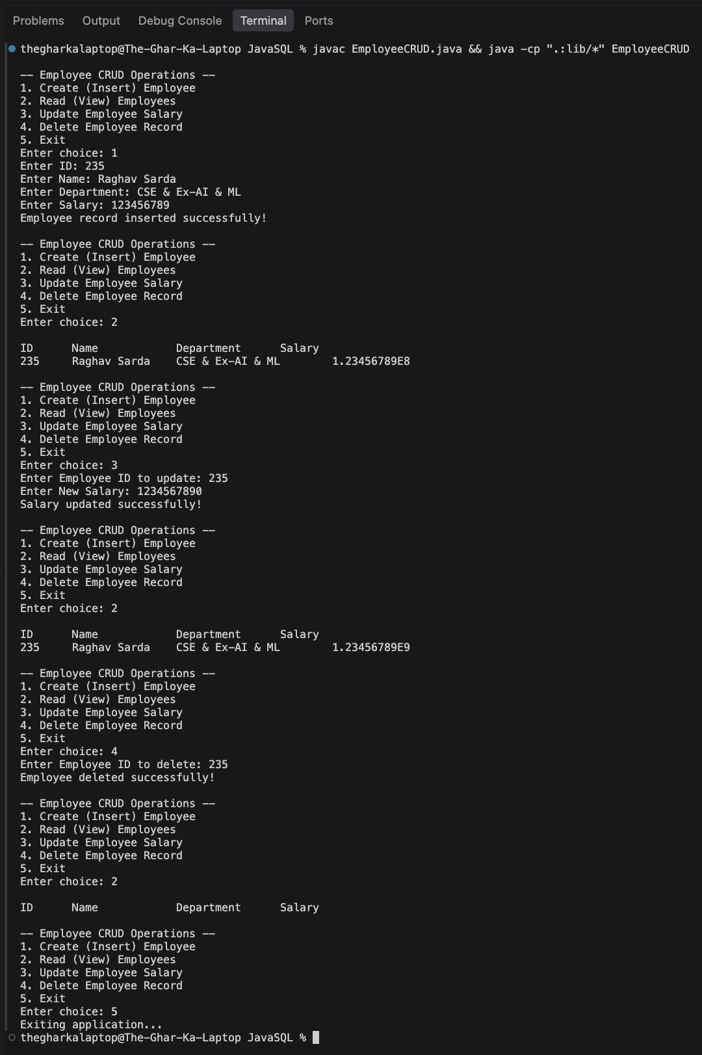

StudentCRUD.java
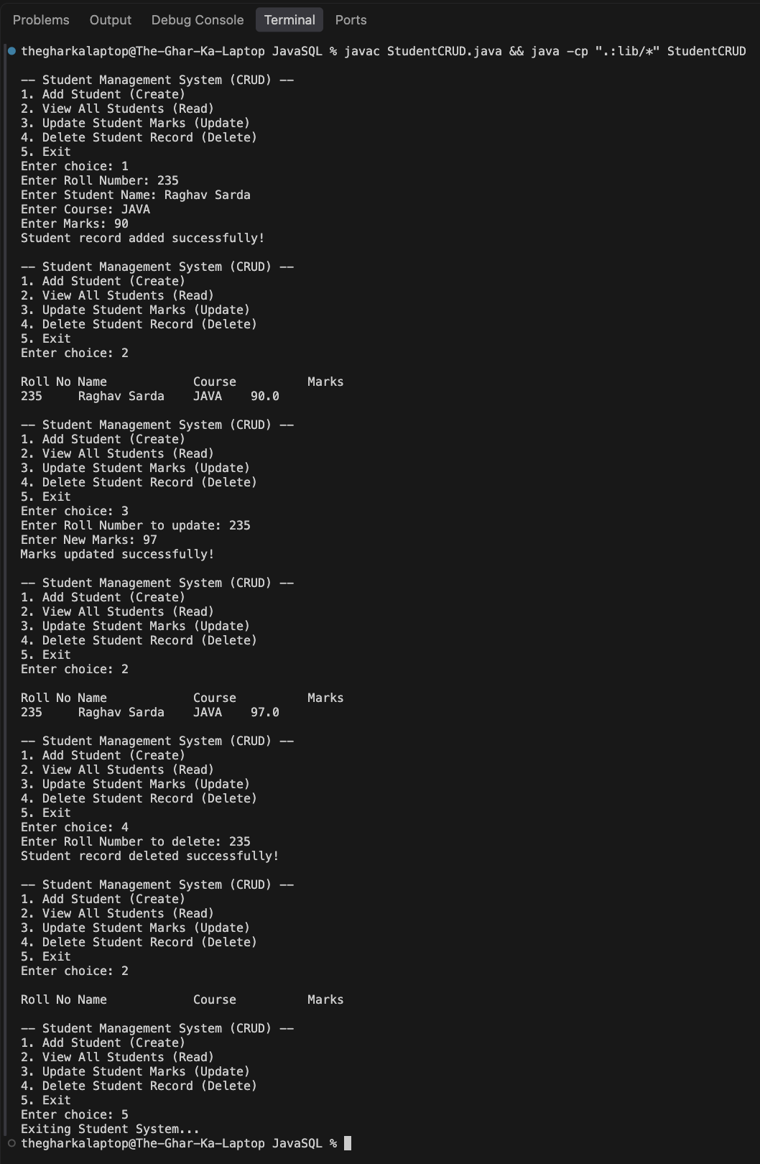
Conclusion:
In this assignment, relational database modification operations comprising INSERT, UPDATE, and DELETE were successfully implemented and verified through JDBC. Using PreparedStatement enabled parameterized query execution, preventing SQL injection vulnerabilities while managing entities for employee and student records. The continuous menu-driven operations demonstrated transactional integrity and accurate synchronization between user input and database storage.

